

**SPE-211244-MS**

**Advanced Analytics and Diagnostic Rules Automatically Notify Operators About Developing Failures in Rotating and Reciprocating Machines**

Downloaded from <http://onepetro.org/SPEADIP/proceedings-pdf/22ADIP/2-22ADIP/D021S038R002/3042094/spe-211244-ms.pdf> by Fayyaz Karim Qureshi on 07 February 2023

Fayyaz Karim Qureshi and Abdelhady A Hady Mohamed, Bently Nevada, a Baker Hughes Business

Copyright 2022, Society of Petroleum Engineers DOI [10.2118/211244-MS](https://dx.doi.org/10.2118/211244-MS)

This paper was prepared for presentation at the ADIPEC held in Abu Dhabi, UAE, 31 October – 3 November 2022.

This paper was selected for presentation by an SPE program committee following review of information contained in an abstract submitted by the author(s). Contents of the paper have not been reviewed by the Society of Petroleum Engineers and are subject to correction by the author(s). The material does not necessarily reflect any position of the Society of Petroleum Engineers, its officers, or members. Electronic reproduction, distribution, or storage of any part of this paper without the written consent of the Society of Petroleum Engineers is prohibited. Permission to reproduce in print is restricted to an abstract of not more than 300 words; illustrations may not be copied. The abstract must contain conspicuous acknowledgment of SPE copyright.



**Abstract**

With the paradigm shift towards digitalization, Operators and service providers are inclined to use technologies that can optimize efforts from workforce by providing meaningful information rather than ‘just’ data, transition subject matter knowledge into machines rather than limiting to people, deploy machine learning techniques to improve systems and leverage this big data to serve on wide scale.

Historically, condition monitoring knowledge has primarily been people-centric and Reliability personnel have to spend hours in front of screen reviewing terabytes of data. Unfortunately, most of the time is spent to find problems rather than finding solutions. Need of the hour is to define automated mechanisms for triggering alerts pointing towards developing malfunctions for which systems are created with embedded knowledge to run the data through pre-configured diagnostic rules and analytics. Through these online systems, operators are able to receive meaningful actionable information about the issue and its source. These analytics are widespread across machinery, auxiliary and process domains.

Through this automated diagnostics platform, Data-driven insights can be generated for machine condition monitoring through advanced rule-building and data-mapping capabilities. In addition to packaged algorithms of known failure signatures, users can also create custom rules that help to capture, disseminate, and leverage knowledge of equipment, processes, and business solutions. For turbomachinery, trending of process parameters, bearing temperature and overall vibration have been used for decades to monitor condition of assets, whereas knowledgeable diagnostic personnel are required to review dynamic data like orbit shape, vibration precession, along with other attributes together to really monitor condition of machine. Now meaningful information from dynamic data can be digitized and attributes can be used in rule logics for automated diagnosis of typical malfunctions like unbalance, misalignment, rubbing, fluid induced instability, rotor bow etc. For reciprocating compressors, automated diagnosis of typical malfunctions like pressure packing leak, valve failures, crosshead pin / frame overloading, debris/liquid ingestion, auxiliary systems (lube oil, cylinder cooling system, unloader etc.) failures and several process related issues can be realized. In this paper, case studies will be demonstrated where users were able to capitalize these systems to identify some of above stated malfunctions and save their assets from expensive secondary repercussions.

An operational analytics software will be demonstrated in detail with elaboration on built-in library of pre­packaged algorithms. A primary consideration is maximizing return-on-investment and minimizing payback

2 SPE-211244-MS

period. Through use case studies, it will be further demonstrated on how the users were able to identify anomalies and relish 100% payback in less than 2 months of deployment.

**Introduction**

Data Analysis for asset condition monitoring is physics-based analogies where certain signatures would signify a certain condition; indeed, there are supplementary evidence to further augment the initial speculation, but eventually physics-based rules and models can cover the data analysis span. Artificial intelligence is the basis behind building these analytics rules which is nothing but simple if-then-else commands in an algorithm. For the sake of discussion and representation, we will be referring to Decision Support analytics software throughout this paper however the applicability is not limited to just this platform.

Downloaded from <http://onepetro.org/SPEADIP/proceedings-pdf/22ADIP/2-22ADIP/D021S038R002/3042094/spe-211244-ms.pdf> by Fayyaz Karim Qureshi on 07 February 2023

To simplify implementation and for a systematic deployment, the rules are divided into 3 categories:

1. *Configured Property rules* can be adapted to suit the unique operational application of a machine or asset. The properties are either peculiar characteristics of a machine from construction or design perspective e.g. bearing clearance, maximum allowable rod load compression or these can be operating limits e.g. maximum allowable 1X vibration, pressure packing case limit. For optimal operationalization, these properties can be made as tunable inputs so these limits can be fine adjusted efficiently.
2. *Extraction rules* combine measurements, statuses, reference values and asset properties to produce a simple set of values/ratios that represent the behavior of the asset.
3. *Diagnostic rules* are a collection of pre-defined rules which deliver values and statuses that represent the health of the asset. The inputs for these rules will come from both the Configured Properties and Extraction Rules Libraries.

**Materials and Methods**

Rotating turbomachines and reciprocating compressors will be explicitly defined in two unique sections to tailor content for target readers.

**Turbomachinery Related Analytics**

For turbomachinery, trending of process parameters, bearing temperature and overall vibration have been used for decades to monitor condition of assets, whereas knowledgeable diagnostic personnel are required to review dynamic data like orbit shape, vibration precession, along with other attributes together to really monitor condition of machine. The intent was to digitize meaningful information from dynamic data and use attributes in rule logics for automated diagnosis of typical malfunctions like unbalance, misalignment, rubbing, fluid induced instability, rotor bow etc.

A set of extraction rules allows detecting changes in machine conditions, and can be trended on their own, used for analysis, or feeding other custom rules, in addition to feeding the diagnostic rules. There is a long list of extractions; some of them are for mechanical systems, others are for process and auxiliaries. Following are just some examples of the extraction results that will come from knowing the bearing clearances, direction of rotation, gap voltage at stopped condition, along with the measurement from X&Y probes.

***Eccentricity Ratio:.*** A dimensionless quantity representing the average position of the shaft within the bearing compared to the available clearance. It is calculated by dividing the distance between the bearing center to the shaft centerline position by the available radial clearance. The eccentricity ratio is zero when the shaft is at the center of the bearing, and one when the shaft is in contact with the bearing wall [1]. This is useful to understand if there are external/internal forces that are abnormal, or abnormal stiffness. The value may exceed 1 as the bearing wears abnormally.

|  |  |  |
| --- | --- | --- |
| SPE-211244-MS 3 |  |  |
|  |  |  |
| ***Shaft Position Angle.*** The shaft position angle is an angle measured between the down position (in a horizontal machine, the direction of the acceleration of gravity) and a line between the center of the bearing and the average shaft centerline position [1]. This is useful to understand if there are abnormal forces, or stiffness, acting on the rotor.  ***Orbit Major Axis Angle (weak axis).*** The angle measured between the down position (in a horizontal machine, the direction of the acceleration of gravity) and a line coinciding with the major axis of the filtered 1X rotor response [1]. This is useful to understand which direction corresponds with the weak stiffness axis restraining the rotor synchronous forces, such as unbalance. A similar extraction for the filtered 2X rotor response is also available which can help determining the preload direction when the source of the 2X is a rotating stiffness asymmetry such as a crack shaft  ***Orbit Minor Axis Angle (stiff axis).*** The angle measured between the down position (in a horizontal machine the direction of the acceleration of gravity) and a line coinciding with the minor axis of the filtered 1X rotor response [1]. This is useful to understand which direction corresponds with the weak stiffness axis restraining the rotor synchronous forces, such as unbalance. A similar extraction for the filtered 2X rotor response is also available which can help determining the preload direction when the source of the 2X is a rotating stiffness asymmetry such as a crack shaft  ***1X Precession Direction.*** Precession is the direction of the dynamic motion of the shaft centerline or basically direction of the orbit and is independent of rotation direction [1]. The blank bright (dot) with the rotation direction helps the user determine the precession direction on the filtered orbit. Therefore, if the precession is in the direction of the rotor rotation it is considered Forward, and against is Reverse. The 1X Precession Direction is the vibration direction of the filtered 1X shaft centerline motion in the XY plane  ***1X Orbit Shape.*** This extraction produces an output called 1X Ellipticity that determines the ellipticity of the Filtered 1X orbit [1]. For the orbit in Figure 1, the 1X Ellipticity = 0.47. | | Downloaded from <http://onepetro.org/SPEADIP/proceedings-pdf/22ADIP/2-22ADIP/D021S038R002/3042094/spe-211244-ms.pdf> by Fayyaz Karim Qureshi on 07 February 2023 |
|  |  |
| **Figure 1—Shaft Centerline and Orbit Plots for Shaft inside Elliptical Bearing** |  |  |

4 SPE-211244-MS

The previously mentioned extractions are just few examples of a long list of extractions, to help understanding the concept.

**Reciprocating Machines Related Analytics**

While reciprocating compressors are famous for the high compression ratios and effective compression on lighter gases like hydrogen, simultaneously they are notorious for higher maintenance costs. Continuous online monitoring of these machines is vital to ensure safety of personnel, assets and environment. Further, comprehensive condition monitoring enables users to make informed decisions using advanced monitoring solutions for optimizing operation and maintenance.

A suite of online machine monitoring instrumentation can help identify mechanical issues on the machine. But to optimize asset operation, process and auxiliaries are equally important. Following mechanical, process and auxiliary related diagnostic rules can be deployed to effectively monitor the condition of most-failing components of the train.

Downloaded from <http://onepetro.org/SPEADIP/proceedings-pdf/22ADIP/2-22ADIP/D021S038R002/3042094/spe-211244-ms.pdf> by Fayyaz Karim Qureshi on 07 February 2023

A compressor reliability survey was carried out by Dresser-Rand approximately 15 years ago and was published in EFRC R&D project on Compressor Reliability Survey [2] (in European Forum for Reciprocating Compressors e. V.). In this survey 217 questionnaires were distributed worldwide and 62 were returned (response quota of 28.6%). The results of this survey are summarized in Figure 2 which illustrates the majority of the reciprocating compressor systems and components identified to result in unscheduled shutdowns. According to the results, eight systems and component areas are responsible for nearly 94% of all unscheduled shutdowns of reciprocating compressors. One interesting result was the ranking of the cylinder lubrication system as one of the top eight problem areas. This was determined to be significant as the reliability of the systems can directly affect the reliability of three other components also ranked among the top eighth problem areas: pressure packings (#2), piston rings (#4) and rider bands (#5).

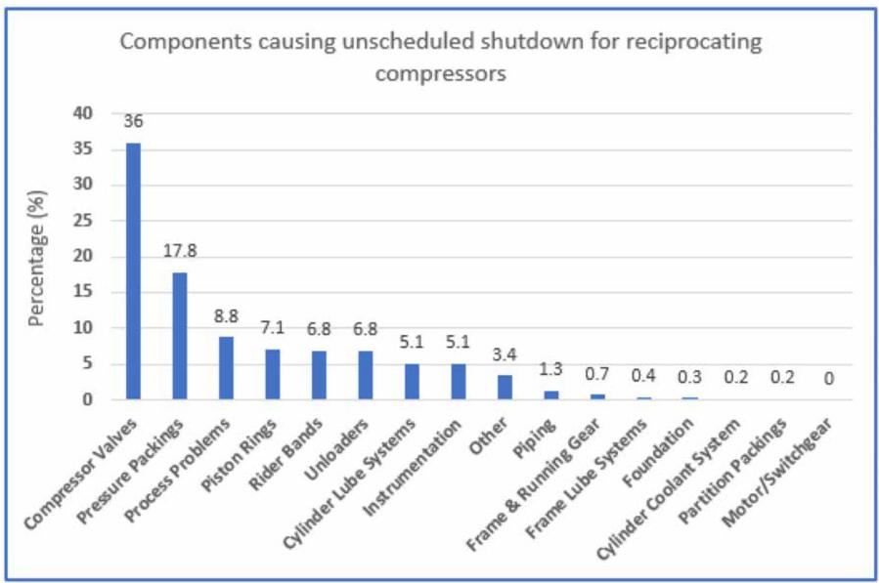

**Figure 2—Components which cause unscheduled shut-down of reciprocating compressors**

***Mechanical Issues:.*** *Valve Failure*: Valves are responsible for the highest maintenance cost [3] and top cause of maximum number of unscheduled shutdowns on reciprocating compressors [4]. The temperature

|  |  |  |
| --- | --- | --- |
| SPE-211244-MS 5 |  |  |
| of each valve is compared with the average temperature of all relevant valves belonging to loaded chambers of the same compression stage. If the temperature difference exceeds a certain threshold, a valve failure notification will trigger pointing to the leaking valve. If dynamic cylinder pressures are monitored as well for performance analysis, the flow balance (ratio of suction capacity to discharge capacity) is compared with its baseline. In case of suction valve leakages, the flow balance exceeds 1.0 (or baseline); discharge valve leakages decrease the flow balance below 1.0 (or baseline). Based on the availability of measurements, the two logics can be ANDed to make analytics more absolute.  *Valve Stiction*: Valve stiction is another common cause of indicated horsepower loss on reciprocating compressors which becomes aggravated on lubricated cylinders in events of over lubrication; due to decomposition of non-metallic consumables (rider bands, piston rings) with lube oil and in cases when the process gas is not clean. Due to valve stiction, moving components of valve collide with higher impacts resulting in degradation of valve life. Maximum pressure (i.e. highest pressure throughout crank rotation) and discharge pressure are compared to identify discharge valve stiction delineating overshoot in pressure curve; as their difference exceeds a certain threshold level, a discharge valve stiction notification is generated in the condition monitoring software. Suction pressure and minimum pressure (i.e. lowest pressure throughout crank rotation) are compared to identify suction valve stiction delineating undershoot in pressure curve; as their difference exceeds a certain threshold level, a suction valve stiction notification is generated in the condition monitoring software.  *Crosshead Pin Overloading*: During severe cylinder trim leakages, peak rod compression and tension may exceed defined rated limits as per compressor datasheet. Moreover, the minimum degrees of rod load reversal may decrease as well. These abnormalities eventually lead to crosshead pin failure (the weakest link across the running gear). Peak rod compression, peak rod tension and degrees of rod load reversal are continuously compared with the rated values and in case of any violation, crosshead pin overloading notification is generated for consideration. Crosshead pin temperature is also an optional measurement (if available) which is compared with pre-defined setpoints and severity 2 alarms are generated when exceeded.  *Pressure Packing Leak*: Packing rings at the stuffing box tend to deteriorate over time and may start to leak eventually. There are safeguards like buffer gas system that can direct the leaking gas to flare or gas recovery systems or scarcely to vent (if the gas compressed is not combustible/explosive) but continuous monitoring is equally important to apprise the operator of upcoming maintenance. Packing case or vent line temperature is compared with setpoints; as the value exceeds a defined threshold, a packing leak notification is generated.  If cylinder pressure monitoring is available, the flow balance in crank end chamber is also compared with its baseline. A pressure packing leak would cause flow balance to exceed 1.0 (or baseline). Based on the availability of measurements, the two logics can be ANDed to make analytics more concrete. Note: In case of cryogenic applications, the packing leak notification should be generated when the temperature goes below pre-defined setpoints as the gas being compressed is at negative temperatures.  *Piston Ring Leak*: Piston rings serve as seal between crank end and head end chambers. They can get damaged / broken eventually resulting in pressure drop and increased discharge gas temperature. In presence of dynamic cylinder pressure monitoring, the flow balance in crank end and the flow balance in head end are compared against their baselines; if both exceed 1.0 (or baseline) AND discharge gas temperature exceeds its pre-defined threshold level, piston ring leak alarm is generated on condition monitoring software.  *Liquid Ingestion*: Liquid inside cylinders can be disastrous for reciprocating compressors and can result in expensive running gear damages. It is important to identify liquid ingestion/gas condensation as soon as it starts to appear and take necessary remedial actions. Crosshead vibration is a recommended shutdown parameter as per API 670 (5th Edition) which is used for automated tripping in case considerable liquid enters cylinder. With crosshead (or cylinder) vibration referenced to crank angle, bands near top dead center (TDC) and bottom dead center (BDC) can be used for liquid ingestion identification in head end chamber and crank | | Downloaded from <http://onepetro.org/SPEADIP/proceedings-pdf/22ADIP/2-22ADIP/D021S038R002/3042094/spe-211244-ms.pdf> by Fayyaz Karim Qureshi on 07 February 2023 |

|  |  |  |
| --- | --- | --- |
| 6 SPE-211244-MS |  |  |
| end chamber respectively. As the vibration amplitudes in these bands exceed pre-defined setpoints, Liquid Ingestion HE and/or Liquid Ingestion CE notifications are raised on condition monitoring platform.  *Machine Power Overloading*: In presence of cylinder dynamic pressure monitoring, indicated horsepower for all cylinders is added together and compared with the lowest of motor rating or compressor frame rating to ensure that the machine loading is not exceeding the design limits. It is rare to see this rule trigger but if it does then this would indicate severe cylinder trim leakages.  *Foundation, Misalignment or Structural Issue*: Frame vibration (typically monitored by low frequency velomitor) is compared with the pre-defined limits. If the value exceeds setpoint, foundation misalignment or structural issue notification is generated on System 1.  *Piston Rod Failure*: From several case studies [5] [6], it is observed that piston rod vibration (peak-to-peak displacement) is the only parameter that gives early indication of an impending piston rod failure. As soon as the crack initiates, piston rod vibration starts to portray an increasing trend. Piston rod vibration (peak-to-peak displacement) in both vertical and horizontal orientations are compared against the pre-defined setpoints. As the vibration exceeds the threshold, piston rod failure notification is triggered on System 1.  *Worn Rider Bands*: One of the primary monitoring parameters for planning maintenance is the current standout between piston and liner. The same is monitored by piston rod probes installed at the pressure packing flange. This rule calculates the current piston-to-liner bottom clearance/standout and reports worn rider band alarm if the current standout goes below the OEM recommended minimum clearance.  *Defective Stepless Unloader*: In case of malfunctioning stepless unloader, the volumetric efficiency in both (crank end and head end) chambers will not be the same; in fact, they will start diverging [7]. The difference in volumetric efficiencies in head end and crank end chambers is compared against baseline threshold; as the difference increases, the notification is triggered on System 1.  *Damaged Crankshaft Main Bearings*: If any main bearing temperature exceeds the alarm setpoint, the corresponding bearing failure diagnostic rule will be triggered. This can be either because of lubrication problems or due to excessive misalignment resulting in rubbing.  ***Process and Auxiliary related issues:.*** Most of the associated process inputs are directly connected to DCS/PLC. They can be imported into condition monitoring platform for analysis via OPC/Modbus communication.  *Choked Intercooler*: The differential pressures across interstage coolers are compared with pre-configured setpoints. In case the differential pressure starts increasing, this would indicate choking in intercooler and relevant notification shall be raised.  *Cylinder Cooling System Failure*: Jacket coolant supply common header temperature and return line temperature from individual cylinders is compared with the pre-defined setpoints. If the inlet temperature goes below the low alarm setpoint, this can result into gas condensation and as discussed, the liquids can be disastrous for reciprocating compressors. If the inlet temperature and/or the return line temperature go too high, this can result into increased gas temperature which can deteriorate non-metallic components in cylinder trim at a faster pace. If any of these inputs go outside the normal operating limits, a notification of cylinder cooling system failure will be triggered on condition monitoring platform for due attention.  *Cylinder Lubricator System Failure*: If the cylinder lubricator pressure is dropped below a certain threshold and/or cylinder lube oil tank level goes outside the pre-defined range, the condition monitoring platform would trigger a notification of cylinder lubricator system failure.  *Choked Lube Oil Filter*: The differential pressure across frame lube oil filter is compared with pre-configured setpoint. In case the differential pressure starts increasing, this would indicate choking in lube oil filter and relevant notification shall be raised.  *Lube Oil System Failure*: The integrity of frame lube oil system is dependent on lube oil sump level, supply pressure and temperature. If any of these parameters go outside the defined limits, Decision Support shall trigger lube oil system failure alarm. | | Downloaded from <http://onepetro.org/SPEADIP/proceedings-pdf/22ADIP/2-22ADIP/D021S038R002/3042094/spe-211244-ms.pdf> by Fayyaz Karim Qureshi on 07 February 2023 |

SPE-211244-MS 7

*Choked Suction Filter*: The differential pressure across suction line filter of each cylinder is compared with pre-configured setpoint. In case the differential pressure starts increasing, this would indicate choking in suction filter and relevant throw notification shall be raised.

*Packing Buffer Gas System Failure*: If the buffer gas supply pressure falls below a certain low limit, the buffer gas will not be able to guide the leaked gas through packing rings to vent/flare which can result in gas leak towards distance piece.

*High Condensate Level*: As the presence of liquid in the system dominates, the condensate level in knock out drums/snubbers would increase. This diagnostic rule monitors condensate levels continuously and compare with pre-defined setpoints. In case of high levels, notification is triggered in System 1 so Operators can take due actions. Note: Operation of reciprocating compressors with substantial amount of liquids for even few revolutions can break running gear components.

Downloaded from <http://onepetro.org/SPEADIP/proceedings-pdf/22ADIP/2-22ADIP/D021S038R002/3042094/spe-211244-ms.pdf> by Fayyaz Karim Qureshi on 07 February 2023

***Instrumentation Issues:.*** *Pressure Transducer Drift*: Overheating or overcooling of pressure transducers can result in bias shift which can eventually lead to incorrect performance calculations and diagnosis. Suction pressure from both crank end and head end pressure transducers are compared. As the difference between the two starts to increase, the transducer with higher suction pressure is notified as probable faulty transducer.

**Custom rules:**

Analytics software gives flexibility to the user to create custom rules specific to his assets and processes. An example of a similar scenario is a slurry pump where customer wanted to know if the debris in slurry was hindering smooth operation of valves. User added a cylinder vibration amplitude check on crank angle before and after the valve opening event. As the vibration amplitude in the crank angle bands before or after valve opening goes high, that would indicate a valve malfunction.

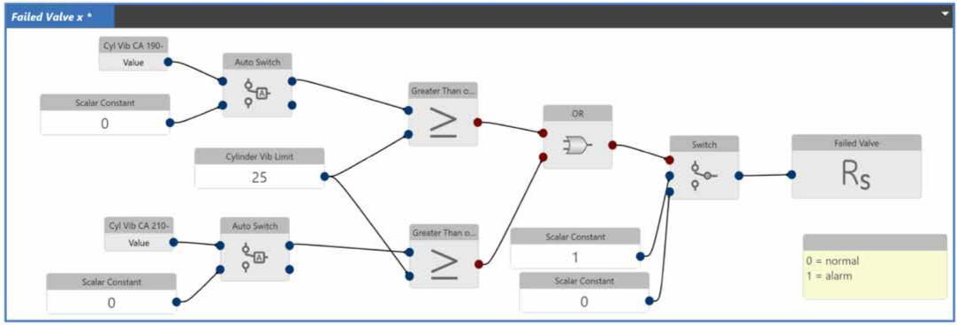

**Figure 3—Custom rule for valve problems on recip pumps**

**Use Case Studies**

Following case studies will present how the users can benefit from a correctly configured and tuned analytics software.

**High Rotor Runout**

Often, the machine protection is configured so that if the vibration of the machine exceeds a predetermined value, the machine will be shut down. The slow-roll runout is essentially the error in the vibration reading. A small slow-roll runout value is an indication that the proximity probes will accurately measure the vibration of the machine. If a machine has high slow-roll runout, then the actual vibration of the machine could be

8 SPE-211244-MS

higher or lower than what is being monitored. Vibration at a particular frequency can be described as a vector that has an amplitude and phase angle. Likewise, the slow-roll runout at the same frequency can be denoted as a vector. Since most vibration on machines normally occurs at rotative (1X) speed, the 1X vibration vector and 1X slow-roll vector will usually characterize the machine quite well. The proximity probe cannot distinguish between these two vectors and therefore will only see the sum. Depending on the phase relationship between the vibration vector and the slow-roll runout vector, the vibration amplitude as measured by the proximity probe can be either larger or smaller than the true vibration amplitude. Two possible extreme scenarios exist. If the slow-roll runout vector is additive to the vibration vector, then the proximity probe will report a larger vibration amplitude than truly exists. This could lead to the situation where the machine goes into an alarm or trip condition prematurely. If, on the other hand, the slow-roll runout vector is subtractive to the vibration vector, then the proximity probe will report a smaller vibration amplitude than truly exits. In this scenario, the true vibration may actually exceed an alarm or trip condition, but the monitoring system will not detect this due to the slow-roll vector making apparent vibration less than real vibration [8].

Downloaded from <http://onepetro.org/SPEADIP/proceedings-pdf/22ADIP/2-22ADIP/D021S038R002/3042094/spe-211244-ms.pdf> by Fayyaz Karim Qureshi on 07 February 2023



**Figure 4—Event Manager showing alarm**

During deployment of Decision Support analytics tool on a motor driven centrifugal pump, it was noticed that severity 2 alarm was triggered for High 1X runout, which was immediately verified by reviewing the Bode plot.

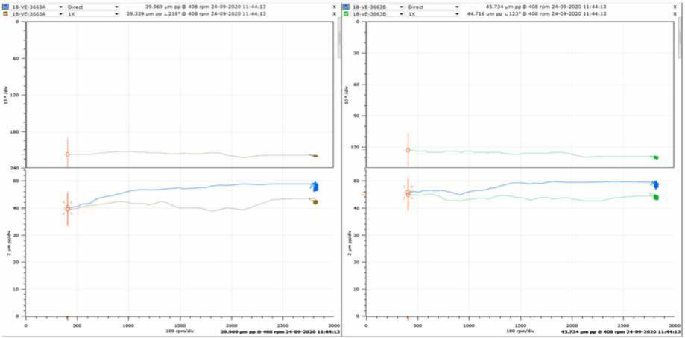

**Figure 5—BODE PLOTS OF DIRECT AND 1X SHOWING HIGH RUNOUT**

After verification from the transient data, plant maintenance team planned the corrective action through a work order in their maintenance management system, to be considered during the next outage to reduce the runout values in compliance with API recommended levels.

SPE-211244-MS 9

**Swapped X/Y probes wiring**

Loop checks are usually conducted during turnaround activities to verify healthiness and correctness of the instrumentation loops, which includes ensuring wiring of the probes, extension cable and field wiring to each designated channel is correct.

During deployment of Decision Support analytics tool at the same site, it was noticed that the 1X Precession Direction extraction is negative (-1) at operating speed, which means that the direction of vibration is against direction of shaft rotation (reverse precession) which is not common in this machine, however it was showing the same (-1) during slow roll speed range which clearly indicate swapped X/Y probe wiring. There was no alarm set for that extraction at this time. However, the issue was immediately verified by looking at the 1X filtered Orbit plot during slow roll speed, which was reverse, and via cascade plot during transient which indicated reverse 1X precession from stopped condition to full speed.

Downloaded from <http://onepetro.org/SPEADIP/proceedings-pdf/22ADIP/2-22ADIP/D021S038R002/3042094/spe-211244-ms.pdf> by Fayyaz Karim Qureshi on 07 February 2023

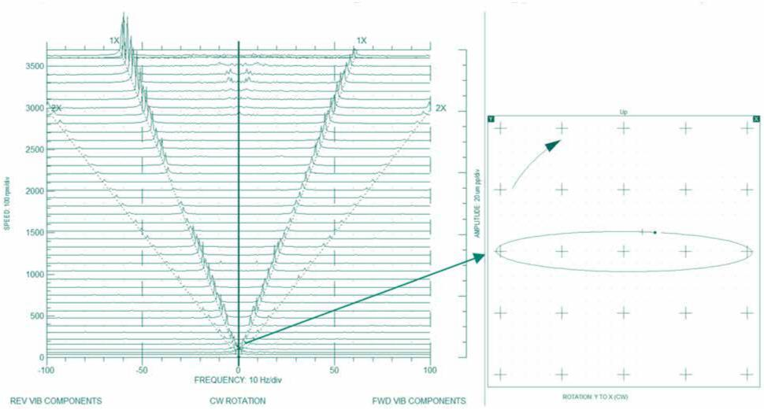

**Figure 6—Cascade (left) and Orbit (right) plots**

The swapped probe issue was brought to attention of the instrumentation team who created a work order in their maintenance management system for correcting the X/Y probes’ wiring connection during next availability.

**Valve Failure Detection**

Valves are the most troublesome components on a reciprocating compressor and consume the highest maintenance costs. Valves can be monitored by dynamic pressure measurements per chamber and by measuring the temperature of the valve at the valve cover/flange or in the gas stream of the valve.

Decision Support analytics software enables pinpointing diagnostics for each suction and discharge valve. Decision Support compares the temperature of a suction (or discharge valve) with the average suction valve (or discharge valve) temperature per compression stage. By doing so, small deviations can be quickly detected. This diagnostic rule is independent of operating condition changes such as different speeds, loads or compression ratio changes.

*Background:* After the successful deployment of Decision Support Analytics suite on 5 reciprocating compressors in a refinery, the customer received a severity 2 software alarm in System 1 condition monitoring platform related to Suction Valve Wear, Damage or Dirt pinpointing to a particular valve.

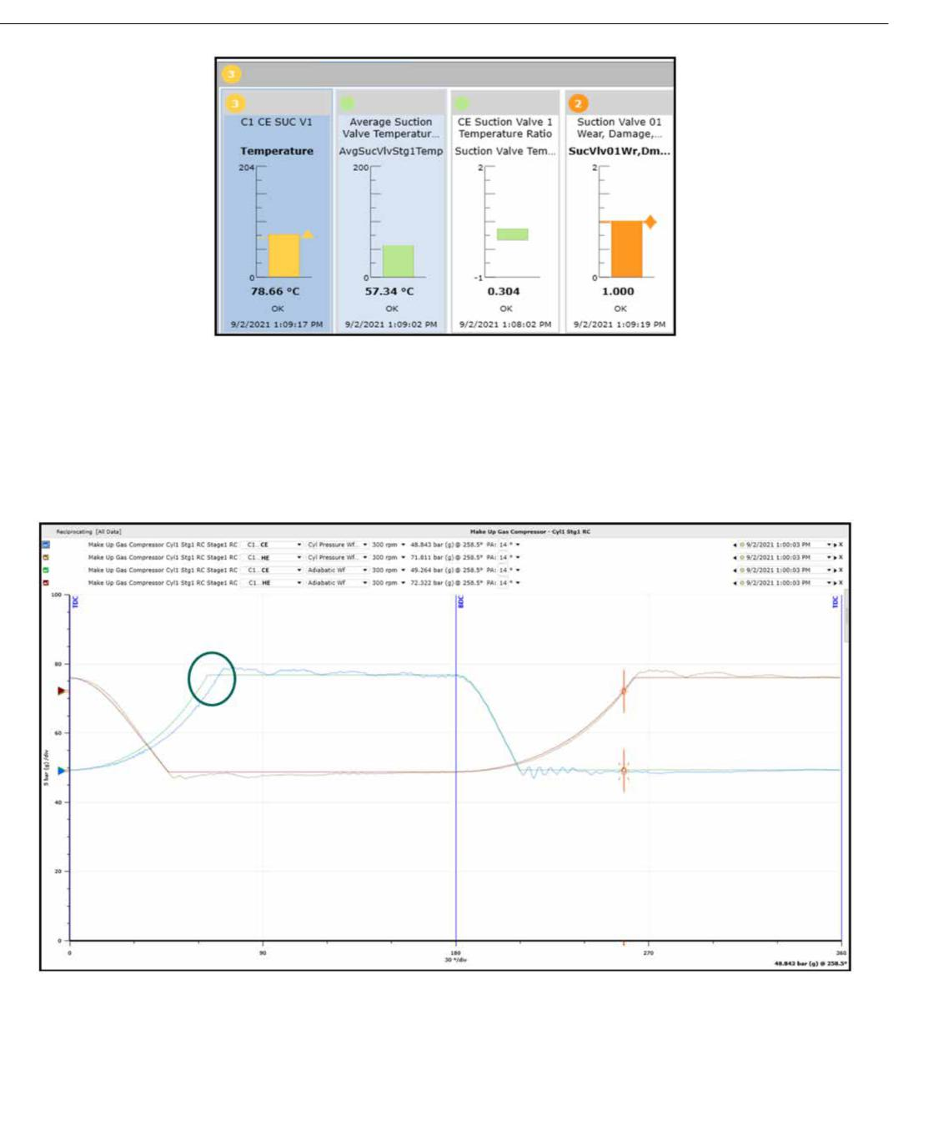

10 SPE-211244-MS

**Figure 7—Relevant Bargraphs**

When the crank angle based plot of the dynamic pressures was referred, it was confirmed that the crank end compression curve was taking longer to reach discharge pressure due to a leak to the low pressure side. The compression curve in the crank end chamber of actual pressure (blue) is rising slower than the expected / ideal (green).

**Figure 8—Pressure vs Crank Angle plot (PT curve)**

The above shown PT plot indicates either a crank end suction valve leak or a pressure packing leak. To identify the exact root cause, the suction valve temperature and packing case temperature need to be referred. The suction valve temperature trend was found to be increasing over time which confirmed the malfunction of suction valve leak.

Downloaded from <http://onepetro.org/SPEADIP/proceedings-pdf/22ADIP/2-22ADIP/D021S038R002/3042094/spe-211244-ms.pdf> by Fayyaz Karim Qureshi on 07 February 2023

SPE-211244-MS 11

Downloaded from <http://onepetro.org/SPEADIP/proceedings-pdf/22ADIP/2-22ADIP/D021S038R002/3042094/spe-211244-ms.pdf> by Fayyaz Karim Qureshi on 07 February 2023

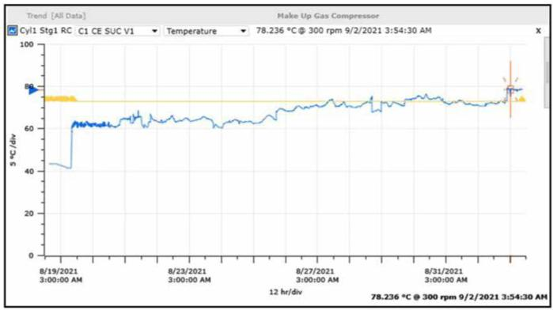

**Figure 9—Suction Valve Temperature Trend**

Decision Support guided staff directly to the leaking valve. The valve failure was detected automatically in an early stage and enabled planned maintenance avoiding an unscheduled outage. If this failure was not detected and valve failure could progress, this could have resulted in prolonged operation of compressor with a continuous increased 100kWh horsepower / energy consumption. Advanced stages of this failure could employ overloading. The end user had 100% payback of the purchase and installation of the Decision Support Analytics on this machine in less than 2 months.

**Cylinder Cooling System Malfunction Detection**

Sometimes, inspection and reliability teams are biased towards machine monitoring parameters and tend to forget the auxiliaries that can directly or indirectly affect the performance of assets.

During deployment of Decision Support analytics tool on a fleet of 9 reciprocating compressors at a refinery, as soon as the configuration and mapping for one compressor train was completed, it was noticed that a severity 1 alarm triggered on cylinder (jacket) cooling system failure diagnostic rule. Further investigation revealed that the tempered water supply temperature was lower than the low limit defined in configured properties.

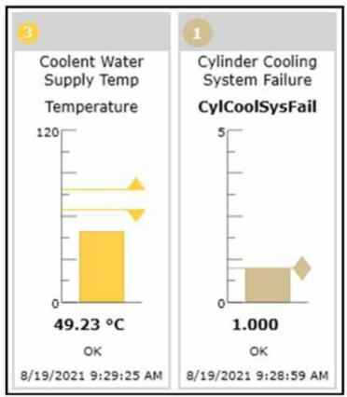

**Figure 10—Relevant Bargraphs**

12 SPE-211244-MS

Downloaded from <http://onepetro.org/SPEADIP/proceedings-pdf/22ADIP/2-22ADIP/D021S038R002/3042094/spe-211244-ms.pdf> by Fayyaz Karim Qureshi on 07 February 2023

The alarms generated from Decision Support drew staff's attention to System 1 for investigation. They quickly confirmed the analytics’ findings by reviewing the trends on System 1 for process inputs and further confirmed the data in DCS. Operations took notice and added this to work order in SAP for maintenance.

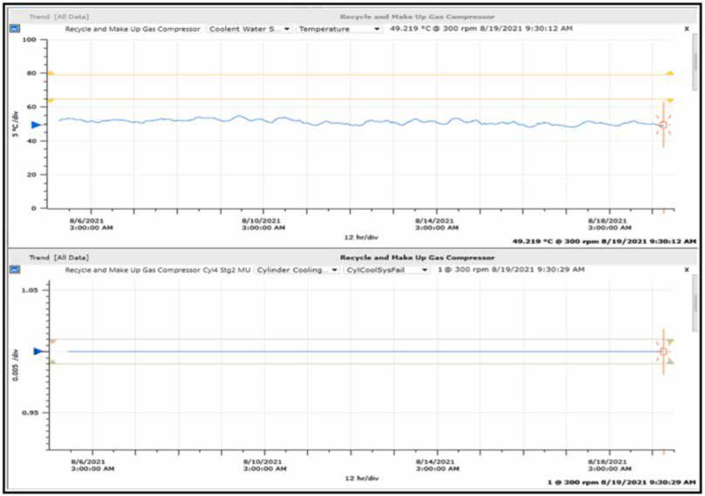

**Figure 11—Trends (Upper: Coolant Inlet temperature; Lower: Rule Result)**

Through notification, the staff was able to quickly identify a failing auxiliary system i.e. cylinder cooling water system. If this failure was not detected, decreased tempered supply water temperature could have resulted in gas condensation which would eventually cause liquid ingestion inside cylinders which can be disastrous for compressor as the impacts while compressing liquids can break running gear components in no time.

**CONCLUSION**

The advanced analytics and auto-diagnosis software is need of the hour to maximize the utilization of workforce and systems as they help in directing towards the issues and their source. However, they cannot completely replace the diagnostic personnel experience and decisions. To validate the root cause of the developing issue, data analysis with correlations and to devise mitigation strategies to avoid reoccurrences, reliability personnel still play a vital role.

**REFERENCES**

1. "Fundamentals of Rotating Machinery Diagnostics", Donald E. Bently and Charles T. Hatch. 2002
2. EFRC R&D project on Compressor Reliability Survey; *European Forµm for Reciprocating Compressors e. V*.
3. "Monitoring Reciprocating Compressors", *Presented to the NPRA*, 1997.
4. "Increasing the reliability of reciprocating compressors on hydrogen service", *Hydrocarbon Processing*, 1996

SPE-211244-MS 13

Downloaded from <http://onepetro.org/SPEADIP/proceedings-pdf/22ADIP/2-22ADIP/D021S038R002/3042094/spe-211244-ms.pdf> by Fayyaz Karim Qureshi on 07 February 2023

1. "Online condition monitoring system identifies developing faults in reciprocating compressor at the very outset", *ADIPEC SPE*, 2018
2. "What's going on with my recip? How uncommon failure modes get detected.", 12th EFRC Conference, 2021
3. <whttps://my.bakerhughes.com/sites/ds-site/News/343036/natref-achieves-optimal-operation-through-bently-nevada-s-comprehensive-reciprocating-compressors-condition-monitoring-system>
4. Vol.**27** No.2 2007 *ORBIT Article* 49